**Locator page approach and issue.**

1. I have able to access the Login api with the help of postman and the user id, password provided form JnJ team, I was also able to call the specialty api and locator api as well inside postman.

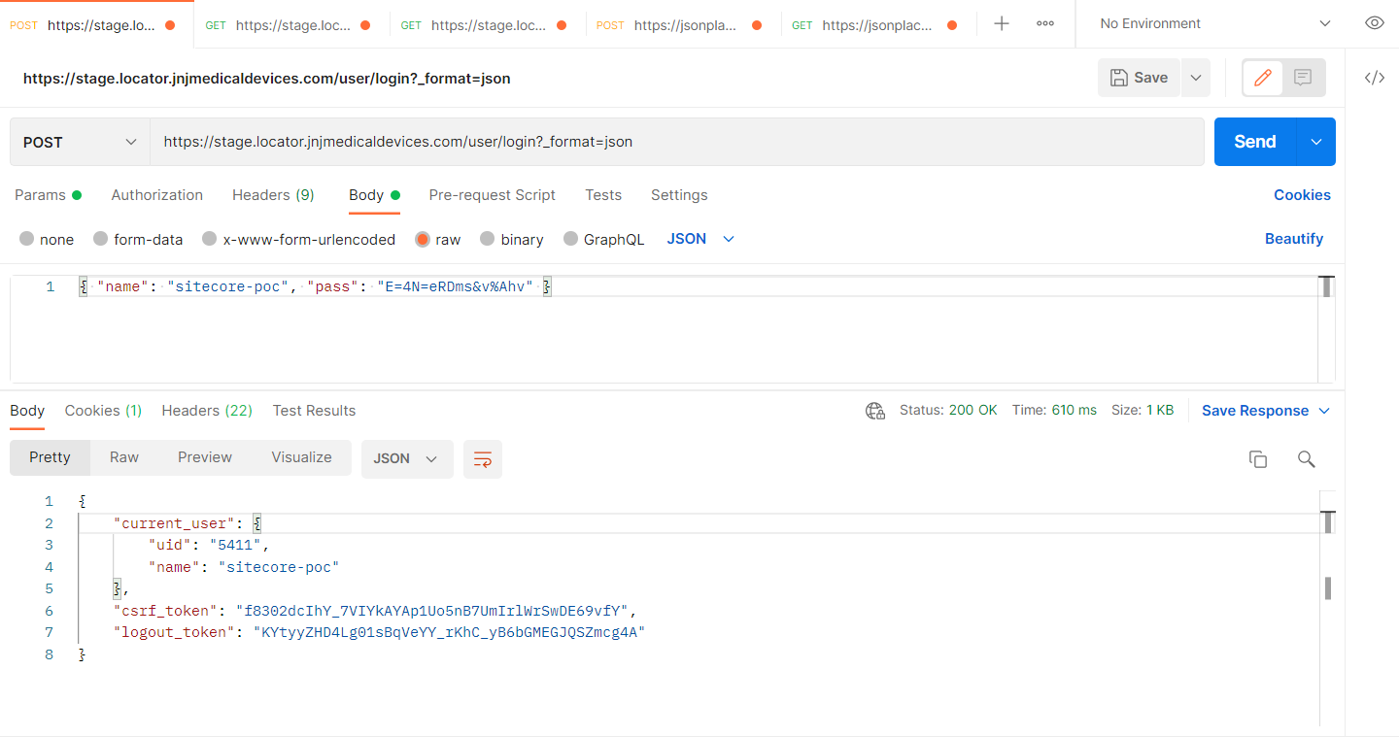

1. Then we have used the JavaScript to call the api but this method is unsuccessful because of Cors error.

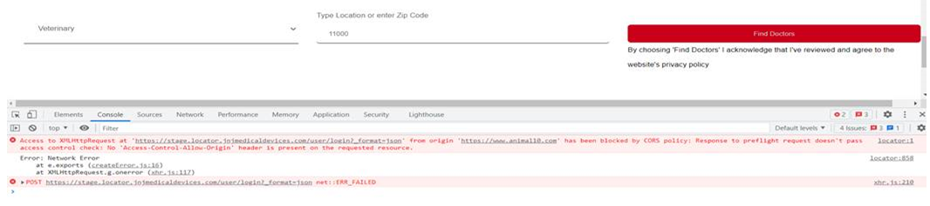

1. Second, we use the normal C# code approach to call the Login api but could not get pass through the below error. 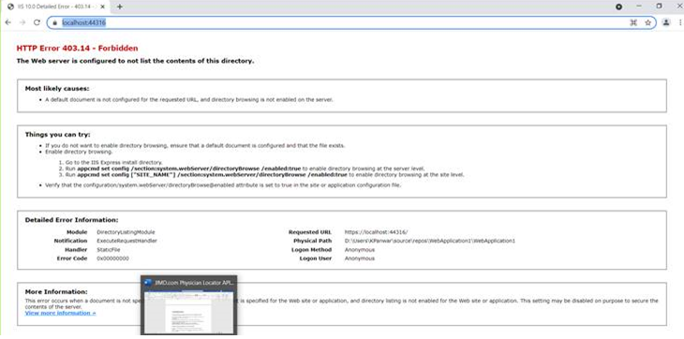
2. Third, I have used the async method with MVC approch and hard setted the csrf token to call the specialty and locator api but could not get pass through the below error.

